Rocket Propulsion Analysis Suite
By: Tristan Hindorff

The goal of this project is to create a python-based tool kit for estimating the output variables of a rocket engine. Then using the provided outputs to create graph demonstrating the relationship between the variables and the optimal values for performance. An emphasis on the ISP, nozzle shape and thrust was used in the analysis.

Thrust produced by the engine is one of the most important metrics generated and is needed for understanding the engine’s power. It’s Newton’s 3rd law at its finest as the force form the fuel combustion pushes the rocket in the opposite direction. The engine’s nozzle is critical in determining the output of thrust produced. The specific impulse of a rocket engine is one of its best measures of efficiency and how well it can impact the thrust produced. The main factors are the expansion ratio and chamber pressure of the engine. The expansion ratio impacts the size of the engine from its neck to the end of the nozzle and effects the total energy output of the engine. While the chamber pressure helps to ensure a smooth flow of fuel into the engine, allowing for greater thrust. It is worth noting that while the higher values will increase performance, they do have diminishing returns.

The output values were calculated using python code with the chamber pressure, chamber temperature, specific heat ratio (constant), specific gas constant, throat area, exit area and ambient pressure. The ambient pressure was changed for each calculation for sea level and space to account for different engine types. This information was used to calculate the area ratio, exit mach number, exit temperature, exit pressure, exit velocity, mass flow rate, thrust and specific impulse.
The calculations performed followed the thermodynamics and dynamics equations for calculating the exit variables. The exception being the mach number which follows the equation $ϵ=\frac{1}{M_{e}}{\left[\frac{2}{r+1}\left(1+\frac{r-1}{2}*M_{e}^{2}\right)\right]}^{\frac{r+1}{2\left(r-1\right)}}$. Given the complexity of the equation, the function of the SciPy fsolve was used in python to perform the calculation. This produced the values in an accurate and efficient manner. The mach number is a critical value derived from the continuity equation and isentropic flow relations measuring the speed the gas leaves the engine based on the speed of sound. As the equations show it has a positive relationship with the area ratio which impacts the thrust produced. It also has a negative relationship with the exit pressure, meaning that more energy can be extracted from the system.
picture
Throughout all the calculations it is important to note that key assumptions were being made in the equations. This being ideal gas, steady flow, 1-D flow, isentropic nozzle, heat ratio and chamber temperature. All these values were constant for all calculations as seen in the data file of the code. With the code all set up and working the input values were set to match the RS-25 engine used on the NASA Space Shuttle.
 | Actual Value | Calculated Value | Percent Error
Expansion Ratio | 69 | 69 | 0.0%
Mass Flow | 514 Kg/s | 519.6 Kg/s | 1.1%
Thrust | 1.86 MN | 1.49 MN | 19.9%
ISP | 366 s | 292.9 s | 20.0%

The values produced by the code are comparable to the true values engine. Some of these are more than others since there are multiple changing factors during flight which were kept constant during the calculations. This includes the mass flow and expansion ratio. The largest difference is with the specific impulse due to the ideal gas being assumed as constant when it actually changes during the launch. The isentropic flow is also a key factor in the nozzle changing as the flight progresses. In a real combustion cycle, energy will escape through the wall making it unable to be used in the production of thrust. This is a critical thing overlooked in the calculation of performance that will also values like the ISP and thrust. Throughout the process the specific heat ratio is also changing when in the calculations it is considered a constant. These factors show the sources and reasons for errors in the calculations produced.
Graphs were then produced to show the key relationships that impact the specifications of the rocket engine. This was created by using the plot function and for loops to produce the values needed for the dependent data points. All the graph are below. The keynote here is that the ambient pressure is at sea level. The relationships change when the engine operates in space and as it climbs through the atmosphere.

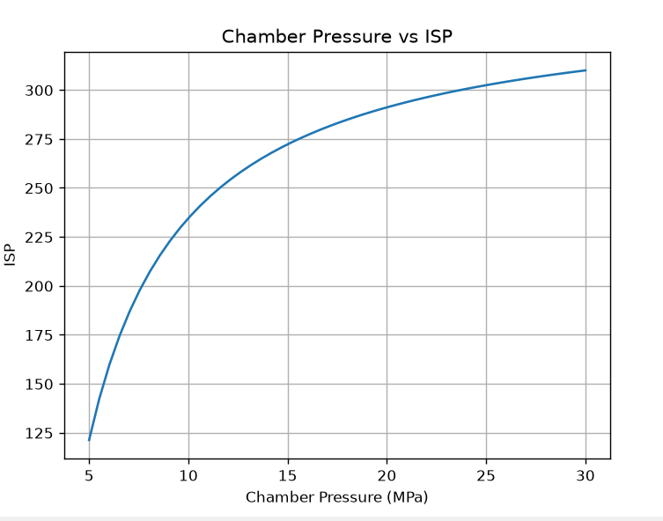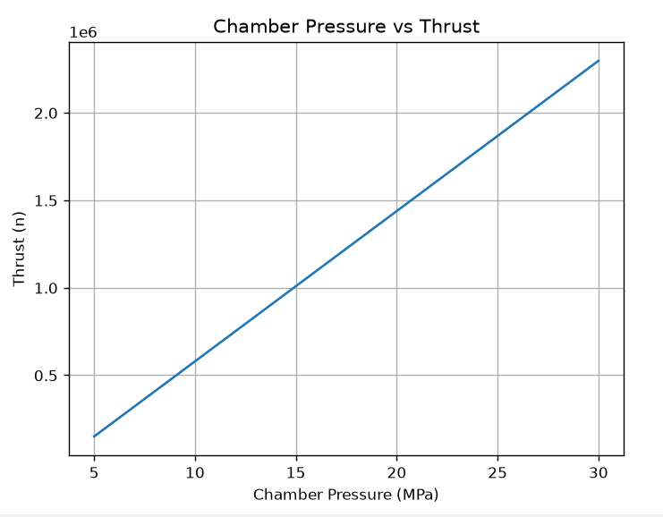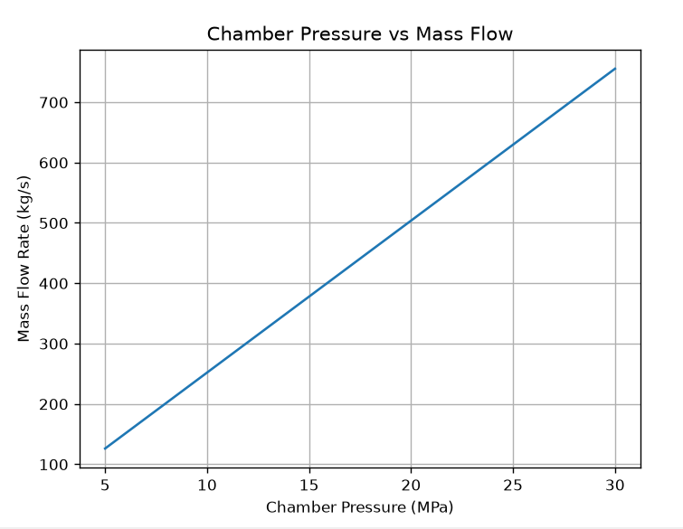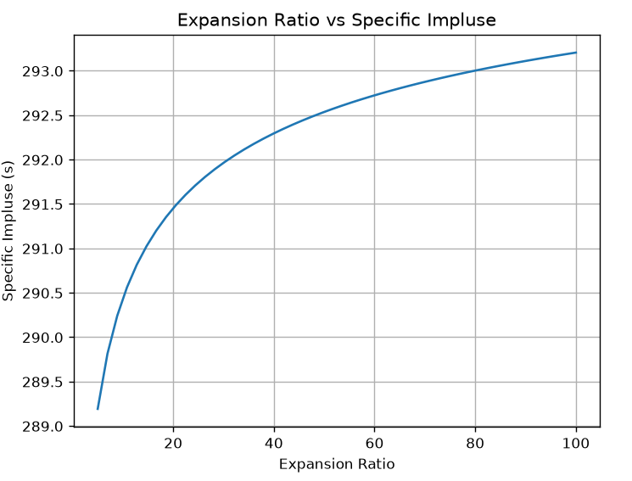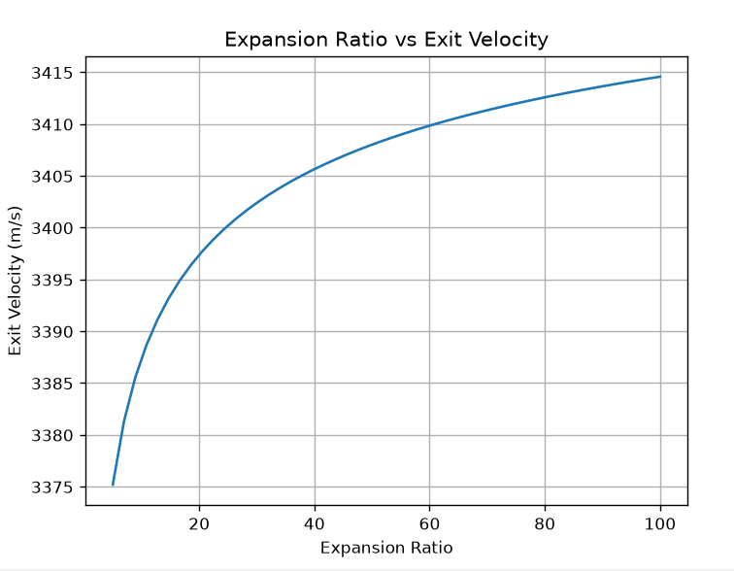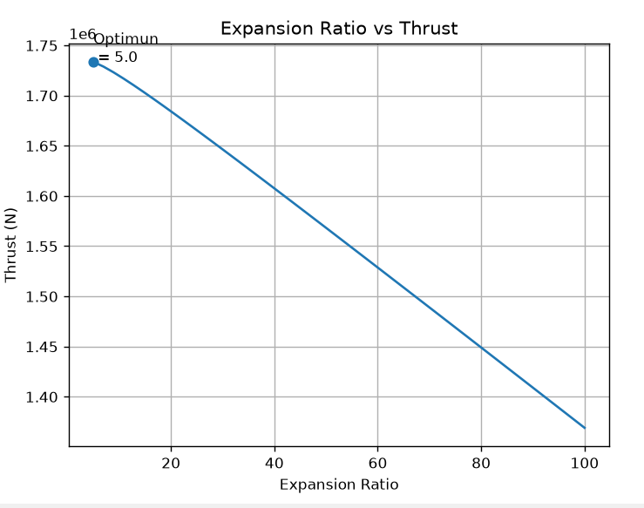

The graphs show that any increase in the chamber pressure will result in an increase in thrust and mass flow rate. This is expected since these values are very closely related as the mass flow rate is a component of thrust. The chamber pressure also impacts the ISP with diminishing returns. A higher pressure will make the engine more efficient but at a certain point it is not worth the cost of development for small gains. The RS-25’s specific impulse is higher among this curve but not at a small increase rate, showing the importance of the chamber pressure for ideal efficiency. The expansion ratio also has the same effect with the exit velocity and specific impulse. While the larger nozzle helps to increase these values there is a point where the change will be negligible.
The main graph of focus is the expansion ratio compared to thrust. At sea level the point on the graph marks the best and therefore ideal expansion ratio for maximum thrust. In space the results are flipped, and the largest expansion ratio becomes the most ideal. This showcases the need for sea level and vacuum engines. The change in pressure throughout the journey into space constantly changes the need for the best expansion ratio for thrust. Since the RS-25 is designed for sea level and vacuum conditions, its higher expansion ratio shows the design choice made. Throughout this whole process the specific impulse is steady, demonstrating that chamber pressure has more of an impact on power output rather than efficiency.

There are many important variables that go into designing a rocket engine. The variables are constantly changing and the rocket climbs into the atmosphere and into space. Sea level and vacuum engines need to be optimized for the respective environments in order to be efficient. Chamber pressure and the expansion ratio of the nozzle are critical factors in determining the right thrust and efficiency as needed by the vehicle. The RS-25’s was designed for both operations, meaning that sacrifices were made when it came to operating in specific conditions. This worked through by reducing engine production and needing multiple different engines for operations. This feature was critical for space shuttle missions.

